# Data Science

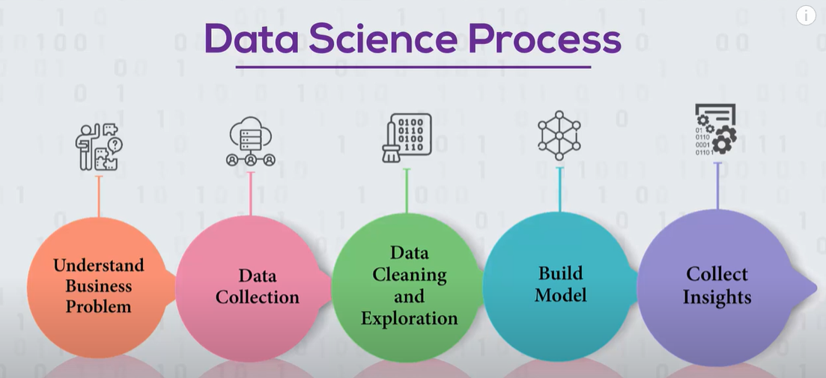

# applications

## Health care

Predict disease based on measuring wearable divide. Monitoring sleeping patters to predict heart disease.

# Statistics

<https://www.youtube.com/watch?v=Lv0xcdeXaGU>

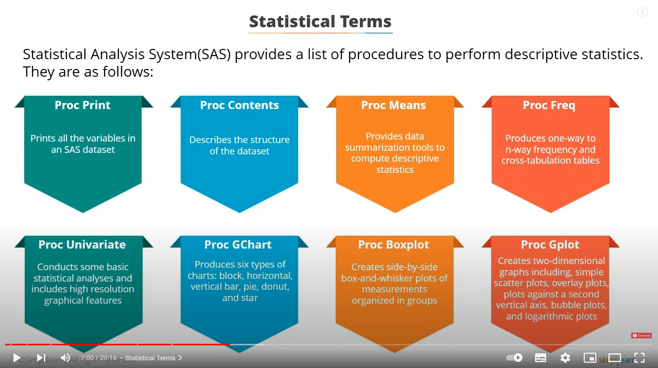

## scipy